Reversible Oxygen Sorption in MOFs

***Matthew R. Hill1,2****, Leena Melag2, Ashley Sutton1, Kiyonori Suzuki3 and M. Munir Sadiq2*

1. *CSIRO, Victoria, Australia*
2. *Monash University, Department of Chemical and Biological Engineering, Victoria, Australia*
3. *Monash University, Department of Mechanical Engineering, Victoria, Australia*

[*matthew.hill@csiro.au](mailto:*matthew.hill@csiro.au), [matthew.hill@monash.edu](mailto:matthew.hill@monash.edu),

<http://www.matthewrhill.com.au>

Sub topic - Health-care and Food

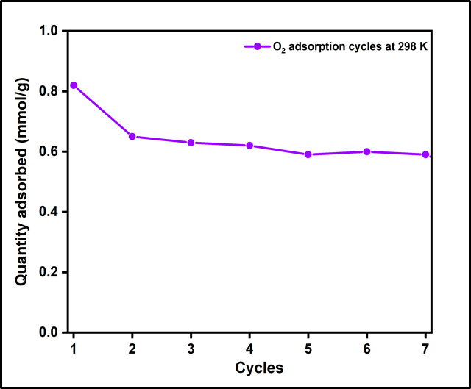Oxygen is a critically important gas for medical and industrial settings. Much of today's global oxygen supply is *via* inefficient technologies such as cryogenic distillation, membranes or zeolites. MOFs promise a superior alternative for oxygen separation, as their fundamental chemistry can in principle be tailored for reversible and selective oxygen capture. In this presentation, we report the discovery of a MOFs family that can reversibly capture and release oxygen at room temperature, for the first time.



**Figure 1. An approach to controllable redox active metal placement within MOFs has lead to reversible oxygen capture at room temperature.**

The key problem has been that the only way to get significant adsorption of oxygen at room temperature is to utilise a redox active site in the material. The interaction is often too strong, which means you need very high temperatures to regenerate the material, which then typically falls apart after a couple of cycles. Our discovery1 has been to controllably space out the redox active sites with other metals, and more recently we’ve managed to use non-toxic metals to achieve this. Mossbauer and XPS analysis also indicate that the spacing seems to affect the redox states of the active metal, weakening the redox interaction strength as well, and improving the stability for the reasons listed above.

This presentation will highlight the latest results with detailed analysis of the mechanism and overall performance metrics, with a view to predicting the feasibility of these materials being applied to personal oxygen concentrator devices.

**Bio: Professor Matthew Hill**

Matthew is a technical leader in the field of clean and renewable energy research with 15 years’ experience in delivering technical solutions to government and industry across 52 projects worth $ 38M AUD. An inorganic chemist by training , he began in the field of MOFs in 2008 with Prof Jeffrey Long in the area of hydrogen storage materials. He has over 130 publications, 17 patents and over 9000 citations.

1. M.R. Hill, A. Sutton, L Melag, K Suzuki, M. M. Sadiq, Aus Provisional Patent, 2022.